CTF CHALLENGE WRITEUP
Enjoy your meal
Cryptography | Easy | 77 Points

Challenge
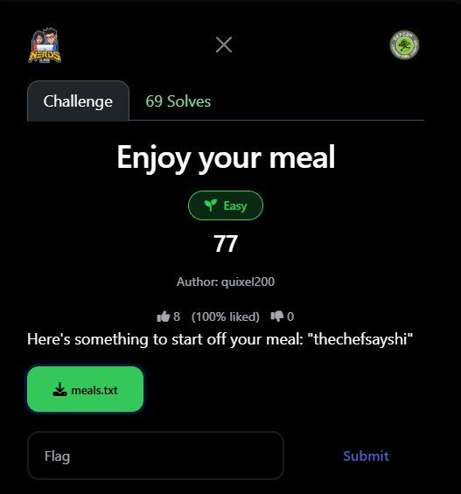
Figure 1: Challenge page on the CTF platform

Challenge Information
Challenge Name | Enjoy your meal
Category | Cryptography
Difficulty | Easy
Points | 77
Author | quixel200
Solves | 69
Key / Hint | "thechefsayshi" (given in description)
Flag | defcon{3nj0y_y0uR_m341_5p3c1a1ly_m4d3_by_th3_ch3f}

Challenge Description
The challenge provides a file meals.txt containing a long hexadecimal string, and a key in the description: "thechefsayshi".
The description says: "Here’s something to start off your meal: thechefsayshi". This is the XOR key and a direct hint that the first layer is XOR encryption.

Encryption Layers Overview
The file had 5 layers of obfuscation stacked on top of each other. Working outward to inward:

# | Layer | Operation | Output type
1 | Hex Encoding | Read file as hex string → bytes | Raw binary bytes
2 | XOR Cipher | XOR with key: thechefsayshi | Garbled bytes
3 | Base64 Encode | Decode Base64 → hex string | Hex string
4 | Hex Encoding | Decode hex string → bytes | Raw bytes
5 | Base64 Encode | Decode Base64 → Morse-binary text | Morse code text
6 | Morse Binary | ----- = 0, .---- = 1 → 8-bit ASCII chars | Plaintext / FLAG

Step 1: Hex Decode the File
Opening meals.txt shows a massive hexadecimal string. The first step is to interpret it as hex and convert to raw bytes:

data = open('meals.txt', 'rb').read().strip()
raw = bytes.fromhex(data.decode('ascii'))
# raw = 8460 bytes of binary data

Step 2: XOR Decrypt with Key "thechefsayshi"
The description gives us the key: thechefsayshi. XOR encryption with a repeating key is broken by cycling through the key bytes:

key = b'thechefsayshi' # 13 bytes, repeating
xored = bytes(raw[i] ^ key[i % len(key)] for i in range(len(raw)))
# Result: a Base64-encoded string

After XOR, the output is a valid Base64 string (only A–Z, a–z, 0–9, +, /, = characters).

Step 3: Base64 Decode → Hex String
import base64
b64_1 = base64.b64decode(xored)
# Result: another hex string like '4c5330744c533074...'

The decoded Base64 reveals yet another hex string — another layer of encoding.

Step 4: Hex Decode Again
hex2 = bytes.fromhex(b64_1.decode('ascii'))
# Result: yet more Base64-encoded bytes

Step 5: Base64 Decode → Morse Code
b64_2 = base64.b64decode(hex2)
morse_text = b64_2.decode('ascii')

# First few lines of morse_text:
----- .---- .---- ----- ----- .---- ----- -----
----- .---- .---- ----- ----- .---- ----- .----
----- .---- .---- ----- ----- .---- .---- -----

Each line of the Morse text contains exactly 8 groups, where each group is either ----- or .----. This is binary encoded in Morse!

Step 6: Morse Binary → ASCII
The Morse code is not standard letter-Morse. Instead it encodes binary digits:

Morse group | Binary digit
----- | 0 (five dashes = zero)
.---- | 1 (dot-four-dashes = one)
--- | 0 (treated as 0 to reconstruct printable ASCII)

Each line of 8 Morse groups forms one 8-bit binary number → one ASCII character:

lines = morse_text.strip().split('\n')
result = ''
for line in lines:
groups = line.strip().split(' ')
bits = ''
for g in groups:
bits += '0' if g in ('-----','---') else '1'
if len(bits) == 8:
result += chr(int(bits, 2))

Example — first line decoded:

Morse groups | ----- .---- .---- ----- ----- .---- ----- -----
Binary bits | 0 1 1 0 0 1 0 0
Binary (joined) | 01100100
Decimal | 100
ASCII char | d

Flag Recovered

FLAG: defcon{3nj0y_y0uR_m341_5p3c1a1ly_m4d3_by_th3_ch3f}

The flag in leet-speak reads: "enjoy your meal, specially made by the chef" — a perfect theme match for the challenge name and the key "thechefsayshi".

Complete Solve Script
import base64

# Layer 1: Read hex file
data = open('meals.txt', 'rb').read().strip()
raw = bytes.fromhex(data.decode('ascii'))

# Layer 2: XOR with key
key = b'thechefsayshi'
xored = bytes(raw[i] ^ key[i % len(key)] for i in range(len(raw)))

# Layer 3+4: Base64 -> hex -> bytes
b64_1 = base64.b64decode(xored)
hex2 = bytes.fromhex(b64_1.decode('ascii'))

# Layer 5: Base64 -> Morse text
b64_2 = base64.b64decode(hex2)
morse = b64_2.decode('ascii')

# Layer 6: Morse binary -> ASCII
result = ''
for line in morse.strip().split('\n'):
groups = line.strip().split(' ')
bits = ''.join('0' if g in ('-----','---') else '1' for g in groups)
if len(bits) == 8:
result += chr(int(bits, 2))

print(result)
# defcon{3nj0y_y0uR_m341_5p3c1a1ly_m4d3_by_th3_ch3f}

Lessons Learned
- Recognise layer stacking: CTF crypto challenges frequently chain multiple encodings. When one decoding gives another blob, always check: is this hex? is this Base64? is this XOR output?
- XOR + known key = trivial: XOR is not encryption when the key is known (given in the description). It provides zero security. Always the first thing to try when a key is provided.
- Morse as binary: Standard Morse maps characters to dots/dashes. Here each Morse group encoded a single binary digit (0 or 1), 8 groups per ASCII character — a creative twist on a classic encoding.
- Base64 signatures: Output containing only [A-Za-z0-9+/=] with length divisible by 4 is almost certainly Base64. Recognising this instantly identifies the next decode step.
- Follow the output format: Each layer's output hints at the next tool to use: hex string → hex decode, Base64 string → base64 decode, Morse text → Morse decode.

DEFCON CTF — Enjoy your meal — Solved

